Socio-Technical Security Against Online Games for Cash

Supervisor: Dr David COOK, Edith Cowan University, Joondalup Campus

Team Members:

Pasidu Gangodavilage (10683554)

Kumarage Perera (10672254)

Chenuka Arachchilage (10692299)

Pasini Arachchilage(10643400)

MD Anik (10683287)

Ilhaan Fakeermahamood (10679860)

Project goal: To classify online games offering cash or cash-like rewards by whether real money can actually be withdrawn and who is harmed, and to publish that classification as a public website with an information and guidance chatbot.

1 Problem Statement
People lose real money to online games that were never presented to them as gambling, and they cannot tell which games these are. A child asks a parent for the credit card to buy a sword on undisclosed odds; a retiree buys coin packs in a social-casino app with no withdrawal route and an offshore operator. A scoping review of monetary-format experiments finds the evidence base thin and inconsistent (Palmer et al., 2022). The harm is not only technical: identical mechanics harm different people differently depending on age, gender, financial literacy, cultural attachment to a sport, and the operator's legal reach.

2 Background
Drummond and Sauer (2018) showed that the loot box meets the criteria for gambling, and Zendle and Cairns (2018, 2019) found across two large surveys, the second pre-registered, that loot-box spending correlates with problem-gambling severity. Greer, Murray Boyle and Jenkinson (2022) reviewed 64 outputs linking loot boxes and simulated gambling to gaming disorder, psychological harm and financial loss in adolescents. Hing et al. (2022) found Australian adolescents who engaged in esports skin betting were over three times as likely to meet at-risk criteria. Johnson, Pitt, Randle and Thomas (2023) reviewed 44 studies of older-adult gambling and found the products themselves almost unstudied.
Australia responded through classification rather than gambling law. Since 22 September 2024, paid chance-based purchases carry a minimum M rating and simulated gambling is R18+ (Australian Classification Board, 2024). Current classification systems describe what a game contains, not whether money can be extracted from it, and even that is not done reliably. A preprint by Carter et al. (2025) found that 20% of the top 100 Apple App Store games and 48% on Google Play were wrongly classified. Xiao (2024) documents the same weakly enforced picture internationally, and Harris, Griffiths and Gibson (2025) identified over 50 unlicensed skins sites reachable from the UK, used by 11- to 14-year-olds at more than twice the rate of 22- to 24-year-olds. Where regulators have acted decisively, they have acted on convertibility, not genre. India's Promotion and Regulation of Online Gaming Act 2025, in force from May 2026, prohibits online money games outright, including skill-based formats previously treated as lawful. The Interactive Gambling Act 2001 applies to services played for money or anything of value. This project therefore takes convertibility as its operative test, a working assumption rather than settled law.
Two gaps follow. The field has a mature taxonomy of gambling harms (Langham et al., 2016) and of people, but none of products organised by whether money can come back out and who is exposed. And existing guidance is not answerable at the point of decision: a systematic review found only two eligible chatbot trials, with between-group differences often non-significant, and both treatment-facing, assuming the user already identifies as a problem gambler (Çakmak et al., 2025).
3 Scope

3.1 Proposed work
The main product is a faceted classification of online games offering monetary or monetary-like rewards. It is not a list: each game is described on the same dimensions and may fall into several classes, so Fortnite is both a children's game and a shooter. The dimensions are game type, audience age band, gender and community, monetary mechanics, harm profile (who bears the loss), regulatory status including an offshore or unlicensed flag, financial exposure, and cash realizability.
Cash realisability is the primary axis: can real money ever reach the player's hands? T rise with how readily money can come back out and attach to a game-and-role pair, because a Roblox player cannot convert Robux into cash but a Roblox creator can, through the Developer Exchange (Roblox Corporation, n.d.). Regulatory coverage is recorded separately.
Preliminary scanning identified five documented classes: paid loot-box shooters, social-casino apps, skin-trading and skin-betting ecosystems, cricket and fantasy-sports wagering apps, and children's reward-token games (Greer et al., 2022; Harris et al., 2025; Hing et al., 2022). We expect around 30 classifications in total. The taxonomy is published through two artefacts. A simple website will let a user search for a game name and receive its class, tier, mechanics, audience, plain-language guidance and cited sources. The website houses the entry point for an information and guidance chatbot, which answers plain-language questions by retrieving from the classified dataset and returning the tier, the rule applied, and the dated source behind it. Being retrieval-based over our own data, it generates no free-form advice and refuses clinical, legal, and out-of-scope questions with a referral to support services, so every answer is traceable to a coded entry. The taxonomy's variables will also yield a per-game risk indicator, which supports the taxonomy and is not its aim. Both artefacts are released only with supervisor approval. No human subjects are involved, and no personal data are collected, so ethics approval is not required.
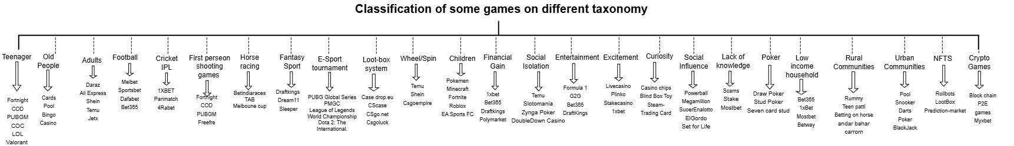
Figure 1. Classification of Game Genres Across Different Taxonomies

3.2 Requirements
Category | Requirement | Priority
Taxonomy Structure | Each class has clear inclusion and exclusion rules; each classification attribute specifies whether one or multiple values are allowed. | Must
Tier Classification | Every game-and-role pair receives a tier by the rule, each citing a dated, verifiable source. (Tiers are in Appendix B) | Must
Coverage & Documentation | 60+ live games classified with three worked examples per classification; each classification records age bands, communities and who is harmed. | Must
Inter-rater Reliability | Two members classify 20 games with agreement per dimension and confidence intervals; chatbot accuracy/refusal tested on a 30-question set. | Should
Website – Privacy & Governance | No personal data collected, no account required; site states outputs are research (not advice) and publishes a correction process. | Must
Website – Usability | Plain English, mobile-usable, traceable to sources. | Should
Risk & Financial Indicators | Risk indicator uses only taxonomy variables; each class has a financial-exposure rating and ranking. | Should
Chatbot Scope & Privacy | Answers only from dataset (tier, rule, source); refuses clinical/legal/out-of-scope questions; no account, no conversation data retained. | Must
Table 1. Requirements. ( Tiers are located in Appendix B)

3.3 Deliverables
# | Deliverable | Description
D1 | Taxonomy specification | Dimensions, classification rules, coding manual.
D2 | Classified dataset | CSV/JSON of 60+ games coded on every dimension.
D3 | Validation report | Cohen's κ (nominal facets), Krippendorff's α (ordinal tiers), with 95% CIs; rule changes.
D4 | Website (deployed) | Search, profile, tier, guidance, sources, chatbot entry.
D5 | Guidance chatbot | Intents, answer templates, refusal rules, evaluation.
D6 | Source code repository | Source, schema, seed data, build instructions.
D7 | User and dev guides | Reading a classification; architecture, hand-over.
D8 | Final report and slides | Report, traceability matrix, indicator Report, traceability matrix, indicator spec, slides.
Table 2. Deliverables
.

4 Schedule
Week | Work undertaken | Milestone/evaluation point
1 | Team formation, learning plan, signing the contract | Team contract signed
2 | Prepare project schedule, background review and initial draft | Internal team review
3 | Taxonomy, supervisor review project proposal submission | Proposal signed off
4 | Discussion with the supervisor and initial draft | Taxonomy v0.1 reviewed
5 | Coding manual, evidence gathering, web sprint | Coding manual agreed
6 | First 30 games researched and tested | Internal team review
7 | Taxonomy v0.5 test on 20 games and Inter-rater reliability | Taxonomy v0.5
8 | Coding to 60+ games, website prototype 1, system testing | Prototype 1 reviewed
9 | Taxonomy v1.0 frozen, chatbot rules built. | Taxonomy v1.0 frozen
10 | Prototype 2, chatbot evaluated, testing | Prototype 2 evaluated
11 | Website and chatbot deployed; guides written. | Deployed for review
12 | Final report; presentation; hand-over. | Final submission
Table 3. Twelve-week schedule and milestones

5 Team Capability Alignment
Workstreams, not personal allocations: all six members classify games and contribute to every workstream
Team Member's Name | Degree/Major | Role in  Project | Task and Aligned Course Learning Outcome (CLO)
Pasidu Gangodavilage | Bachelor of Science (Cybersecurity) | Project Manager |  | They plan meetings and timelines‚ outlines tasks‚ communicate progress‚ while others take minutes and track progress․CLO: Apply structured analysis to security problems
Chenuka Arachchilage | Computer Science, Major in Cyber Security | Project Research Coordinator |  | Leads work on online cash-based games‚ socio-technical determinants and affected groups‚ and others support this research and analysis․ CLO: Locate‚ evaluate and synthesise the relevant sources․
MD Anik | Bachelor of Science (Cybersecurity) | Developer |  | Leads development of the proposed solution and components․ Other roles provide input on design‚ review‚ and refinement as needed․ CLO: Verify solutions against requirements․
Ilhaan Fakeermahamood | Bachelor of Science (Cybersecurity) | Data Analyst |  | Leads organization‚ classification and analysis of project data and taxonomy; others help with data collection and classification․ CLO: Design‚ build and test software․
Kumarage Perera | Bachelor of Computer Science, Major in Cybersecurity | Assistant  Project Manager |  | In support of project coordination‚ following progress and meetings‚ and deliverables; others to maintain progress․ CLO: Apply testing to a delivered system.
Pasini Arachchilage | Bachelor of Science (Cybersecurity) | Documentation and Quality Coordinator |  | Leads: documentation‚ evaluation and testing of outputs; others assist with project review and evaluation․ CLO: Communicate to professional and lay audiences.
Table 4. Team Capability Alignment

6 Tools, Technical Requirements and Risks
Category | Tool / Software | Purpose
Development Tool | Visual Studio Code (VS Code) | Website coding and development
Version Control & Teamwork | GitHub /Git | Code sharing, version control and team collaboration
UI/UX Design | Figma | Website interface and prototype design
Data Storage & Content | MySQL / GitHub | Store application data and project content
Project Management | Microsoft Project | Task scheduling and Gantt chart
Communication | Microsoft Teams | Team meetings and project communication
Frontend Framework | HTML5/ CSS3/JavaScript | Building the website structure and interactive interface
Backend Framework | Node.js / Express | Handling server logic and chatbot message processing
Chatbot Engine | Dialogflow / Botpress / OpenAI API | Powering chatbot conversation logic and responses
Table 5. Tools, Technical Requirements and Risks

7 Team Contract

1. The subject matter of this contract
This contract sets out how the group will work together for the duration of the project. It records the standards, roles, and processes every member agrees to, so that expectations are clear and disagreements can be resolved quickly and fairly. All members are expected to read, understand, and sign this document before work begins.

2. Norms and Expectations
- The group will agree on a fixed weekly meeting day and time, confirmed at the first meeting and revisited only by group agreement.

- Members need to be punctual and stay until the meeting is formally adjourned.

- Members are expected to attend meetings or notify the group via Microsoft Teams as early as reasonably possible. Those absent must review the minutes and complete their assigned tasks on time.

- All members are expected to be jointly responsible for the quality and timeliness of the group’s overall output, regardless of individual task assignment.

- Members attend prepared and have completed agreed tasks. Everyone has a fair opportunity to contribute, with decisions made by consensus, otherwise by majority vote.

- Microsoft Teams is the primary channel for ongoing group communication, while ECU Email is used for formal communication with the project supervisor.

- All project files are to be stored on a shared OneDrive, split into two documents to keep drafts and final content, with the final one being written and submitted only by the group leader.

- Tasks are assigned based on members’ skills, strengths, and availability, ensuring a fair workload while larger tasks may be split or completed collaboratively.

- All tasks, owners, and deadlines are to be recorded in the weekly minutes.

- All work is proofread and checked against the assignment briefly before submission. Contributions to shared deliverables undergo peer review before inclusion in the Primary Document. Sources, data, and code must be accurately referenced, with academic integrity maintained throughout.

- Online meetings are recorded by the group leader or an appointed member solely to support accurate minute-taking. Recordings are shared with group members on request and deleted once the minutes have been confirmed as accurate.

- Concerns regarding participation, work quality, or conduct are addressed progressively: privately with the member, then through group discussion, and finally escalated to the project supervisor if unresolved. Key discussions and agreed actions are documented in the meeting minutes. Non-performance includes repeated unjustified missed deadlines, inadequate contribution, or failure to improve after reasonable notice and opportunity.

- A minimum of three documented incidents, supported by written evidence, is required before requesting a member’s removal. Removal requests must comply with ECU Applied Project procedures.

- This agreement may be amended by unanimous group approval, with all changes, effective dates, and revisions recorded in the meeting minutes.

- Lastly, (RACI) Responsible, Accountable, Consulted and Informed will be used and implemented in every task and deliverable.

3. Names and signatures of the parties to this Group Contract
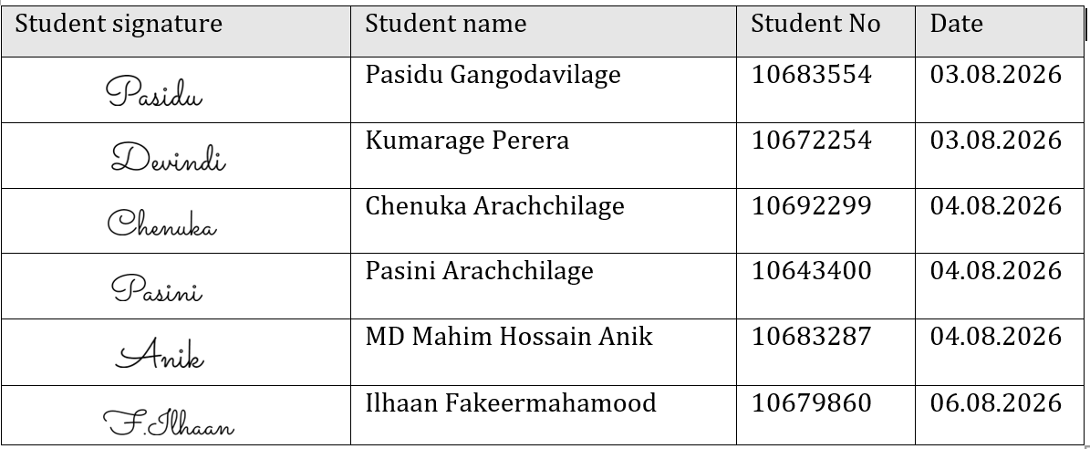

Date of Fully Signed copy given to Supervisor and Unit Coordinator
06.08.2026

References
Australian Classification. (2024). New classifications for gambling-like content in video games. In Classification.gov.au. https://www.classification.gov.au/about-us/media-and-news/news/new-classifications-for-gambling-content-video-games
Çakmak, B., Eyrikaya, E., Salduz, M., & Şenkal Ertürk, İ. (2025). The effect of chatbot interventions on gambling disorder: A systematic review. Journal of Technology in Behavioral Science. https://doi.org/10.1007/s41347-025-00562-7
Carter, M., Zhangshao, T., Hardwick, T., Egliston, B., & Xiao, L. Y. (2025). Investigating mobile games' compliance with Australia's 2024 mandatory minimum age classifications scheme for gambling-like mechanics [Preprint]. SSRN. https://doi.org/10.2139/ssrn.5543999
Drummond, A., & Sauer, J. D. (2018). Video game loot boxes are psychologically akin to gambling. Nature Human Behaviour, 2(8), 530–532. https://doi.org/10.1038/s41562-018-0360-1
Greer, N., Murray Boyle, C., & Jenkinson, R. (2022). Harms associated with loot boxes, simulated gambling and other in-game purchases in video games. Australian Institute of Family Studies. https://aifs.gov.au/research-programs/australian-gambling-research-centre/loot-boxes-simulated-gambling-video-games-harms
for, D. (2025). A rapid evidence review of skins gambling. In GOV.UK. https://www.gov.uk/government/publications/a-rapid-evidence-review-of-skins-gambling
Hing, N., Lole, L., Russell, A. M. T., Rockloff, M., King, D. L., Browne, M., Newall, P., & Greer, N. (2022). Adolescent betting on esports using cash and skins: Links with gaming, monetary gambling, and problematic gambling. PLOS ONE, 17(5), e0266571. https://doi.org/10.1371/journal.pone.0266571
Johnson, R. H., Pitt, H., Randle, M., & Thomas, S. L. (2023). A scoping review of the individual, socio-cultural, environmental and commercial determinants of gambling for older adults: Implications for Public Health Research and Harm Prevention. BMC Public Health, 23(1). https://doi.org/10.1186/s12889-022-14930-y
Langham, E., Thorne, H., Browne, M., Donaldson, P., Rose, J., & Rockloff, M. (2015). Understanding gambling related harm: A proposed definition, conceptual framework, and taxonomy of harms. BMC Public Health, 16(1), 1–23. https://doi.org/10.1186/s12889-016-2747-0
Griffiths, M. D. (2010). The role of chips in poker gambling: An empirical pilot study. 22(1), 34–39. https://www.researchgate.net/publication/273952779_The_role_of_chips_in_poker_gambling_An_empirical_pilot_study
Palmer, L., Cringle, N., & Clark, L. (2022). A scoping review of experimental manipulations examining the impact of monetary format on gambling behaviour. International Gambling Studies, 1–23. https://doi.org/10.1080/14459795.2022.2041067
Parliament of India. (2025). The Promotion and Regulation of Online Gaming Act, 2025. In The Promotion and Regulation of Online Gaming Act, 2025. https://www.meity.gov.in/static/uploads/2025/10/8a7f103cefc68ed8aaa2ebc9a2ed7c13.pdf
Roblox. (2025). Roblox developer Exchange Program. Robloxdevrel. https://create.roblox.com/docs/production/monetization/developer-exchange
Spicer, S. G., Nicklin, L. L., Uther, M., Lloyd, J., Lloyd, H., & Close, J. (2021). Loot boxes, problem gambling and problem video gaming: A systematic review and meta-synthesis. New Media & Society, 24(4), 146144482110271. https://doi.org/10.1177/14614448211027175
Xiao, L. (2024). Loot box state of play 2023: Law, regulation, policy, and enforcement around the world. Gaming Law Review /Gaming Law Review, 1–34. https://doi.org/10.1089/glr2.2024.0006

Appendix A – Gantt Chart
Milestone codes M1–M9 correspond to the schedule table in Section 4.
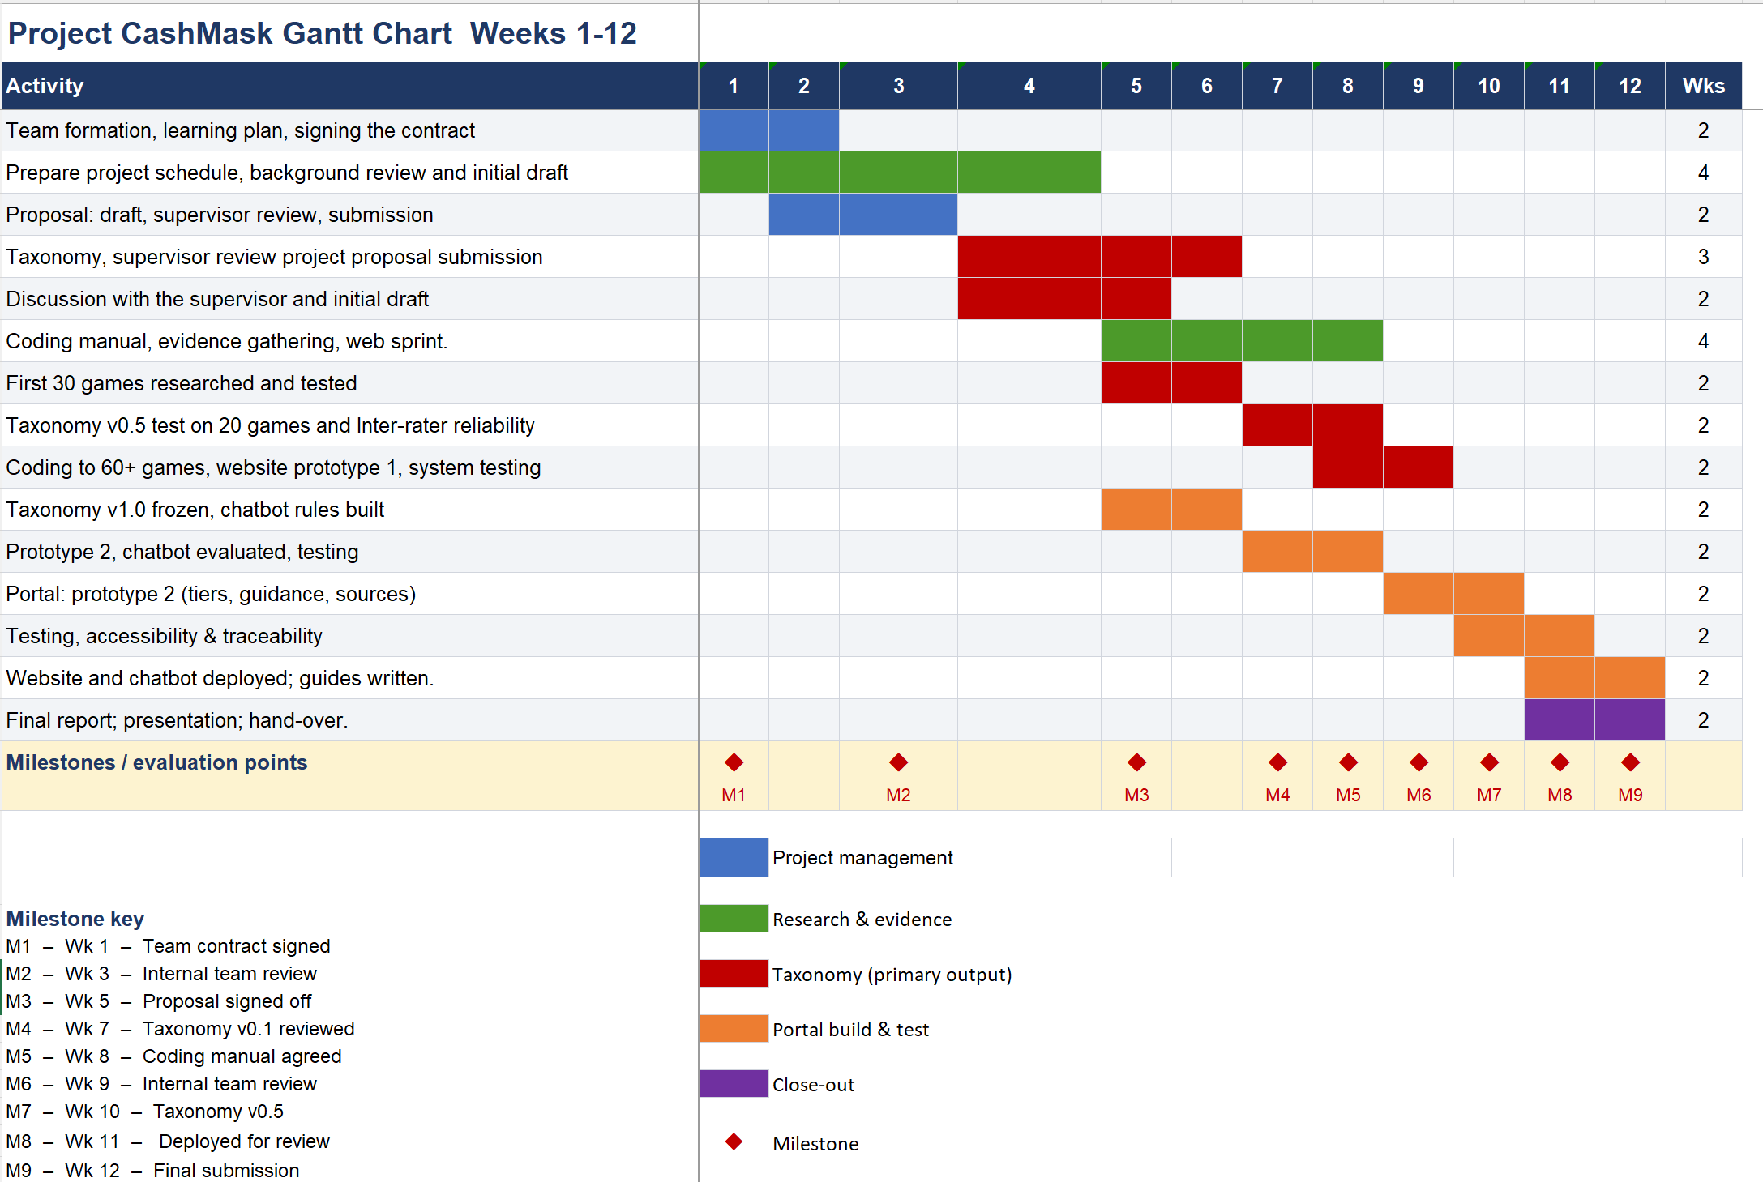
Figure 2: Gantt Chart

Appendix B – Tier Classification

Tier | Definition
T0 | No paid element: the game cannot be paid into.
T1 | Closed-loop paid reward, including direct purchase; items cannot be resold or converted.
T2 | Paid random draw (loot box, gacha, card pack) with no cash-out route.
T3 | Grey-market convertible: item resold for money outside the official platform.
T4 | Token-mediated cash-out: conversion to money via an intermediate currency or programme.
T5 | Licensed real-money wagering under an Australian or comparable licence.
T6 | Unlicensed or offshore real-money wagering.

Candidate class | Cash tier | Primary audience | Worked examples
Paid loot-box shooters/battle royale | T1–T2 | Adolescents, young adults | Apex Legends, Call of Duty: Warzone, Overwatch 2, Fortnite
Children's reward-token games | T1–T2 player; T4 creator | Under 13 | Roblox, Fortnite, Monopoly Go, mobile gacha titles
Social-casino apps | T2–T4 | Adults 45+, older adults | Slotomania, DoubleDown Casino, Zynga Poker
Skin-trading and skin-betting ecosystems | T3–T4 | Adolescent and young adult males | CS2 Steam Community Market, third-party skin sites
Cricket / fantasy-sports wagering apps | T5–T6 | South Asian diaspora adults | Offshore IPL books; free-to-play successors of banned Indian apps
Sports-simulation card packs | T2 | Adolescents, young adults | EA Sports FC Ultimate Team, NBA 2K MyTeam
Collectible card and gacha RPGs | T2 | Adolescents, adults | Genshin Impact, Honkai: Star Rail
Play-to-earn / crypto-token games | T4 | Adults, low-income earners | Axie Infinity, token-reward blockchain games
Sweepstakes “free-to-play” casinos | T4 | Adults | Gold / sweeps-coin dual-currency casinos
Licensed Australian sports wagering | T5 | Adults 18+ | Licensed Australian bookmakers
Offshore/unlicensed bookmakers | T6 | All adults; evades age checks | Mirror-domain operators (e.g. Mahadev network)
Esports match wagering | T5–T6 | Young adult males | Esports betting platforms, skin-based books
Hyper-casual “cash prize” mobile games | T4 | Older adults, casual players | Ad-funded “win real cash” puzzle apps
In-game trading and grey markets | T3 | Adolescents, adults | Steam Community Market, account resale marketplaces
Streamer-promoted gambling content | T5–T6 | Adolescents via exposure | Casino streams, affiliate promotions

Appendix C – Acknowledgement

We would like to sincerely thank our project supervisor for all of their helpful advice, support, and helpful criticism during the creation of this proposal. Their knowledge and assistance have been crucial in determining the project's course.

We also appreciate the School of Science at Edith Cowan University for providing the facilities, learning atmosphere, and academic resources that made this study possible.

Lastly, we would like to thank our project team—Pasidu Gangodavilage, Chenuka Arachchilage, MD Anik, Ilhaan Fakeermahamood, Kumarage Perera, and Pasini Arachchilage—for their hard work, diligence, and cooperation in putting this proposal together.

